Aaron Niecestro

Independent Study Report

Crime Analysis Research Project
- Introduction

In the past six months and more so lately, the news has been talking about the topic about police officers and how the police are using too much force, too much violence, and how police officers are doing there job incorrectly. When I heard about these events I believed new channels we being too critical of police officers. So the research this project aims to do is see if communities have a different perception then what news stories and news channels are suggesting about police officers. The research we are doing was trying to determine if there is a difference in public perception on male and female officers then what the news channels are saying. There wasn’t much data on the public perception of police officers, but we could get data on the number of officers by their sex, the number of crimes being committed, and the police reports. We believe we were able to collect so little data was because very few police departments are willing to place data in a public domain. This is because the numbers of their male and female police officers, and gender discrimination is a controversial topic as of late, always getting more criticism. The news loves to point out the faults in stories and events, but when it comes to what went right we hear nothing. So, we started to form this research topic from this view, and wished to see if the news was accurate in their statements. With little data to be acquired in the United States, we searched other countries, mainly Europe and Canada. Eventually, we found enough data to use in Canada.

Through hours of searching we found CANSIM. CANSIM is an online database that is one of Canada's key socioeconomic databases that the public may access without needing permission. CANSIM is updated daily by its administrators, and it provides fast and easy access to a large range of the latest statistics available in Canada. We collected data on a variety of topics that we were willing to share with people. It’s a reliable source with the government’s approval to post their findings. This gave us confidence in using their data to complete our research.
We found six surveys about perception of police officers, each survey with its own view of how male and female police officers are perceived by a community. However the survey questions that were used were not with the published data. The data included information on Canada and thirteen provinces. The data also included the following categories, male, female, and both, males and females together. From here it was broken down by the publics perception of police enforcing the law, based on a rating of good job, average or poor job, or do not know or was not statement. After we were shown what each sex of the officer received we were able to see by the number of votes in thousands and a percentage of each. It should be noted that these surveys were taken from Canadian residents who were 15 years or older and were willing to take the survey and we excluded the do not know do not know or was not statement category from our research since it would yield not results.
The surveys were broken in to six categories. The first survey was about how well the police officers was doing their job in when it came to enforcing the law. The second survey was regarding the speed at which police responded to calls. The third survey was regarding how police were being approachable and easy to talk to. The fourth survey was regarding how well police were supplying information to the public on ways to prevent crime. The fifth survey was about how people viewed local police regarding ensuring neighborhood safety. The last survey was about whom the public viewed local police officers regarding treating people fairly. From these six surveys, we are able to get a good idea of the community views on how police officers are doing their job and if the sex of the police officers makes a difference on the community’s outlook.
- Descriptive Statistics
Following the questions completion, we had to compile all the data we collected into an excel file, clean it, and then upload the file into R-studio. Then we created some histograms, box and whisker plots, and scatters plots to see what the rough outlook of this data looks like. This way before running any statistical tests we could tell if there were any trends or patterns in the data that should be noted later. From there we tried to figure out which statistical tests we had at our disposal. Just from the box and whisker plot and scatter plots with running we could start to notice a pattern in the good and average numbers among the surveys. We started to see that a lot more people voted that male officers do a better job then female officers in each of the six surveys when it comes to the good job category. (See Graph 1.1 and Graph 1.2 in Appendixes). However, when it comes to average or poor rating a lot more people voted on female officers have a lot more numbers then male officers. The numbers and percentages across the thirteen provinces were sporadic so we did not have to worry about this study ending too soon if all the numbers are percentages were almost the same. It was interesting to see that the numbers and percentages did not match. One would believe that the larger the number the more the percent will be, but this philosophy does not hold in this dataset. As we can see in the appendix, the number and percentages do not match completely. We now know that even if one province has such a large amount of good voting number this does not mean that there percentage will also be equally as large.
- Methodology
After the data cleansing we applied the Cochran–Mantel–Haenszel (CMH) test, and from those results the individual chi-squared test for each province in each survey. The Cochran–Mantel–Haenszel test is designed for when you have a 2×2 table with data that you’ve collected that repeats either at different times, or locations, depending on which you are using, and after running the rest one will be able to see if the data suggests whether or not one has a consistent difference in proportions across the data.
The way we were testing the CHM test is to see whether or not our data was significant or insignificant. Being significant meant that the test results for that particular survey had a p-value less then 0.05 and had there was heterogeneity across the provinces. Being insignificant meant that the test in that survey had a p-value greater then 0.05 and there was homogeneity across the provinces. We used these different tests and the p-value results to see if we might be able to determine how communities view police efforts.
Together we ran four different types of CHM tests. The first CHM, we ran the CHM test with all of the data we collected but after reviewing the numbers we saw that there were outliers that could be skewing our results. The second CHM test, we decided to take out Yukon, Northwest Territories, and Nunavut because the numbers were in single digits compared to the other numbers in three digits. The third CHM test we excluded Prince Edwards Islands because the numbers here were only double digits while the others were all in the thousands place. The last CHM test we had only Yukon, Northwest Territories, Nunavut and Prince Edwards Islands to see if these outliers were significant or insignificant. We did this to fully comprehend if these supposed outliers were real outliers or not. After the four CHM tests we conducted individual chi-squared tests on every province. We ran individual chi-squared tests to find out if each individual province saw police efforts the same or different. If the p-value in the chi-squared tests were greater then 0.05 then we know that that province saw police efforts in that survey as the same and the police were doing a good job.
- Results
The Cochran–Mantel–Haenszel (CMH) test and individual chi-squared tests showed us something very interesting. Each survey in the first three CHM tests said that there was heterogeneity across the provinces and the fourth CHM test said there was homogeneity across the provinces.
  - Survey 1
In the first Cochran–Mantel–Haenszel test we ran the p-value were 9.6e-09 for survey 1. This told us that the first CHM test was significant, and maybe running a second CHM would change the results. After running the second CHM test we found that he p-value was 1.028e-08 for survey 1. As we can see from the result the p-value increased, which is interesting because we took out he smallest numbers, but this is plausible because the rest of the numbers were so close to one another. The third CHM test we found the p-value for survey 1 was 1.286e-08. As one can tell the p-value increased once more, so it seems that our theory that if we take out the outliers the remaining numbers will become close to one another increasing the p-value and lowering any chance of the test being significant. The fourth CHM test was the most interesting because the p-value was 0.3941. This shows us that the four provinces, Yukon, Northwest Territories, Nunavut, and Prince Edward Islands, all had numbers that were so close to one another that the results were homogenous.
After running the four CHM tests and finding out that survey 1 was heterogenic, for nine of the thirteen province, we need to run the individual chi-squared test for those nine remaining provinces. Through the individual thirteen chi-squared we will be able to tell which provinces viewed police efforts differently and thought that there was a difference in male and female police officers in doing a good and average job. The results for the individual chi-squared test in survey one were as follows, the provinces that were significant (p-values < 0.05) were Province 4 = Alberta, province 5 = British Columbia, province 12 = Quebec and province 13 = Ontario. The respective p-values for these provinces were 0.004983 for Alberta, 0.001504 for British Columbia, 0.04032 for Quebec, and 0.007463 for Ontario. It is important to note that these four provinces may not highly significant, but there are still significant. The other five provinces were all insignificant. From this we can see that four provinces (about 3/10 or 30.77% of all the 13 provinces) thought that male and female officers were doing their job differently in good and average results.
  - Survey 2
In the first CHM test we ran for survey two the p-value was 4.097e-09, which is significant, so we have to run the second CHM test. The second CHM test the p-value was 3.662e-09, still significant even with three provinces removed so we have to run the third CHM test. The third CHM test the p-value was 3.686e-09, still highly significant. As one can see even with nine provinces out of the original thirteen we started with the p-value was still significant indicating that there heterogeneity across the nine provinces. The fourth CHM test the p-value was 1, as it is impossible to get a higher p-value then this, we can include that there was homogeneity across Yukon, Northwest Territories, and Nunavut.
With nine provinces still remaining we need to know which of the nine provinces, if any, had homogeneity and heterogeneity in them, so we used the individual chi-squared test. We found that the provinces that were significant (p-values < 0.05) were Alberta, British Columbia, New Brunswick, and Ontario. The p-values for each of these provinces were 0.006124 for Alberta, 6.285e-07 for British Columbia, 0.007163 for New Brunswick, and 0.03147 for Ontario. The other provinces were all insignificant. From this we can see that 4 provinces (about 3/10 or 30.77% of all the 13 provinces) thought that male and female officers were doing their job differently in good and average results. This was the same result as survey 1, so about approximately 30.77% of the provinces think that there is a difference in male and female officers doing their job to serve and help their communities.
  - Survey 3
In the first CHM test we ran for survey 3 the p-value was < 2.2e-16, < 2.2e-16 is the smaller p-value r-studio can compute. This shows us that there is a high significance of heterogeneity in the thirteen provinces so far. In the second CHM test our p-value was < 2.2e-16, so we can see there little to no observable change from the first CHM test to the second CHM test. In the third CHM test the p-value was 3.686e-09, as we can see there was a huge change once we eliminated Prince Edwards Island for the CHM test. This shows us that after taking out the smallest provinces we can see that there is still heterogeneity in our results but not as much as all thirteen provinces combined. The fourth CHM test the p-value was 0.7417, as we can see there was homogeneity across Yukon, Northwest Territories, Nunavut, and Prince Edwards Island. This seems to follow the other two survey results we have as well.
With nine provinces still remaining in survey 3 we need to know which of the nine provinces, if any, had homogeneity and heterogeneity in them, so we used the individual chi-squared test. We found that the provinces that were significant (p-values < 0.05) were Alberta, Saskatchewan, New Brunswick, Quebec and Ontario. The individual chi-squared p-values were 0.0001688 for Alberta, 0.007202 for Saskatchewan, 0.02533 for New Brunswick, 2.983e-06 for Quebec, and 0.01525 for Ontario. Quebec is interesting because it is the highest significant p-value we have found so far and suggests that there is something going on there. The rest of the provinces were insignificant. This shows that approximately 38.46% that shows communities view male and female officers doing their job differently in good and average results.
  - Survey 4
In the first CHM test we ran the p-value was 9.87e-11. This shows us that there is a high significance of heterogeneity in the thirteen provinces so far. In the second CHM test our p-value was 9.231e-11. This is following the usual routine of increasing p-values in each additional CHM test we do, while still maintaining significance in the first three CHM tests. In the third CHM test the p-value we found was 1e-10, which is still significant. So we can conclude of the nine provinces remaining, there is heterogeneity across the nine of them. The fourth CHM test the p-value was 0.7694, which is insignificant, telling us that there homogeneity across the four provinces.
With nine provinces still remaining in survey 4 we need to know which of the nine provinces, if any, had homogeneity and heterogeneity in them, so we used the individual chi-squared test. We found that the province that was significant (p-values < 0.05) was British Columbia with a p-value of 0.02237. This is interesting because the p-value in the CHM test showed us that there was a high amount of heterogeneity but when testing the individual chi-squared test we found only one province. The other twelve provinces were insignificant.
  - Survey 5
In the first CHM test we ran for survey 5 the p-value was 2.017e-06. The second CHM test we ran the p-value was 2.026e-06. The third CHM test we ran the p-value was 1.925e-06. As we can tell from the previous four survey results, the p-value will increase in each additional CHM test we do, while still maintaining significance in the first three CHM tests. In the fourth CHM test the p-value was 0.8819. As we can see the p-value is insignificant indicating that there is homogeneity across the four provinces.
With nine provinces still remaining in survey 4 we need to know which of the nine provinces, if any, had homogeneity and heterogeneity in them, so we used the individual chi-squared test. We found that the province that was significant (p-values < 0.05) was none of the provinces. All of the thirteen provinces had insignificant p-values, signifying that although there is heterogeneity across the nine provinces, individually there is only homogeneity. This means that across the nine provinces, perception of male and female officers differ in rating, but with each individual province the communities feel that male and female officers are doing their job the same. This could be because of the survey or some other phenomenon we are overlooking, but whatever the case, the result is that each community has nothing different to report on with male and female officers and the rating they are given.
  - Survey 6
In the first CHM test we ran for survey 6 the p-values was 0.007344 for survey 6. We can see here that survey 6 had the most interesting result compared to surveys 1 – 5. Survey 6’s p-value has the biggest p-value so far, and one cannot help but wonder why. In the second CHM test we ran the p-value was 0.006657. After running the second CHM test six times, we can see that Yukon, Northwest Territories, and Nunavut definitely were skewing our data. From this we can see that getting rid of those 3 provinces shows us that the other 10 provinces become more homogametic, but they were all still significant so we can still see that there is heterogeneity across the provinces in each survey. In the third CHM test we ran the p-values was 0.006559. Once again we see form removing Prince Edwards Island, which was another outlier the p-values increased once more. From this we can infer the CHM test in the third run is significant and that heterogeneity we had from the first CHM test did not change even when we decreased the number of provinces to nine from thirteen. In the fourth CHM test, the p-value was 0.8791. We see that the fourth CHM test will always give us a homogametic result. This means that across the four provinces we have there is no difference in how the public perceives police efforts in any of the six surveys. After running the four CHM tests we wanted to find out which provinces were homogametic and heterogenic so we ran individual chi-squared tests for each province. Through the individual thirteen chi-squared we will be able to tell which provinces viewed police efforts differently and thought that there was a difference in male and female police officers in doing a good and average job.
In survey 6 the individual chi-squared tests the provinces that were significant (p-values < 0.05) were Alberta with a p-value of 0.001303, British Columbia with a p-value of 0.02663, and Ontario with a p-value of 0.009445. This means that three of the original thirteen provinces have heterogenetic results. These three provinces believe that male and female are doing their job differently in the rating of good and average.
- Conclusion
This research suggests that there are places that have differences in their perception of police officers, but we do not know the cause or the reason behind it. It seems that there is a difference in certain provinces on how the public views male and female officers on their job performance, but we are not able to tell the reason that this might be the case. From this research we can suggest that the recent news stories have been slightly biased to the police officers doing their job incorrectly. This is because the provinces that viewed male and female police officers from doing their job differently in good and average rating were Alberta, British Columbia, and Ontario. The total population in 2015 these three provinces was approximately 22,669.7 thousand and if we compare this number to the total population of Canada in 2015, which is approximately 35,848.6 thousand; it is approximately 63.24% of the population. The only reason this number is so high is because Ontario has a population no 13,797 thousand people in 2015 and is still increasing, otherwise we would not have a majority of the population saying Canadian police are doing their job differently depending on there genetic makeup. However out of thirteen provinces, only three believed that police being doing there job differently while the other ten provinces believed there was no difference. This shows us that although we can have majority of the provinces agreeing that police are doing their job fine regardless of their sex, if we have a big city that is approximately 38.49% of the entire population your results will be skewed slightly. Also being a city police officer and suburban police officers is much different in their job performances. City police will always be under scrutiny for what they do right, and it will make the news, but if it happens in a suburban area, it will not make the news and we will hear nothing about it. So our research suggests that while a majority of Canada believes that male and female officers and doing their job performance differently in good and average votes, this is only the case because of Ontario, which holds a large part of Canada population, otherwise we would have a minority in the perception of police officers doing their job differently.

Appendix

- XY-Plots Section
Graph 1.1 – XY Plot of Good and Average Numbers for the Six Surveys

Graph 1.2 – XY-Plot of Good and Average Percentage Numbers for the Six Surveys

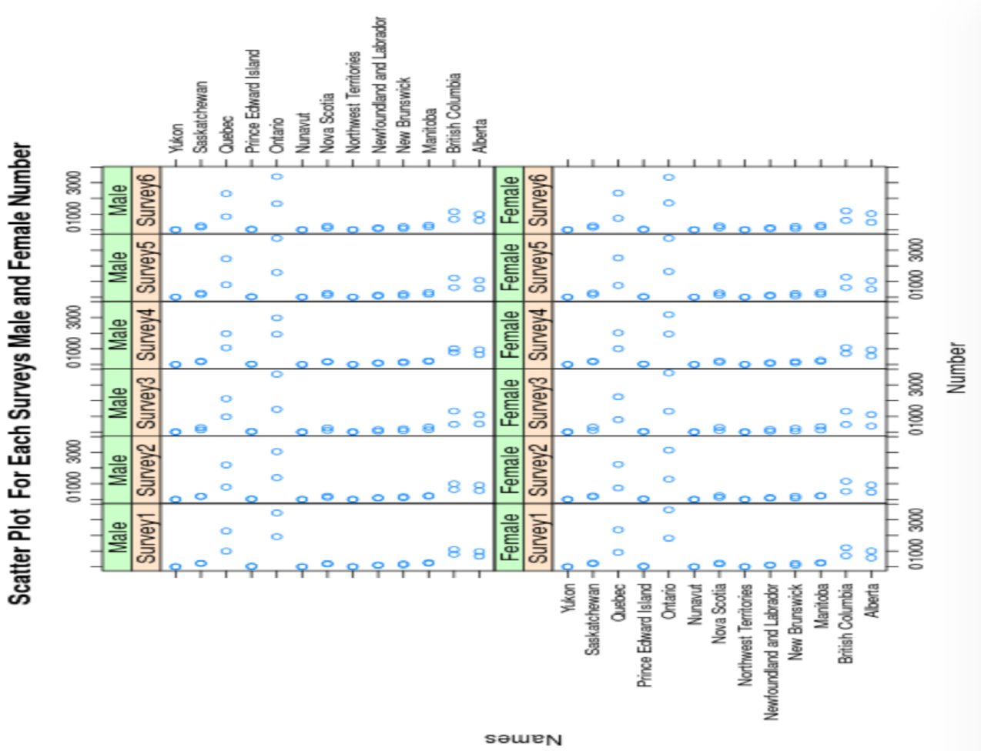
Graph 1.3 - XY-Plot of Male and Female Numbers for the Six Surveys

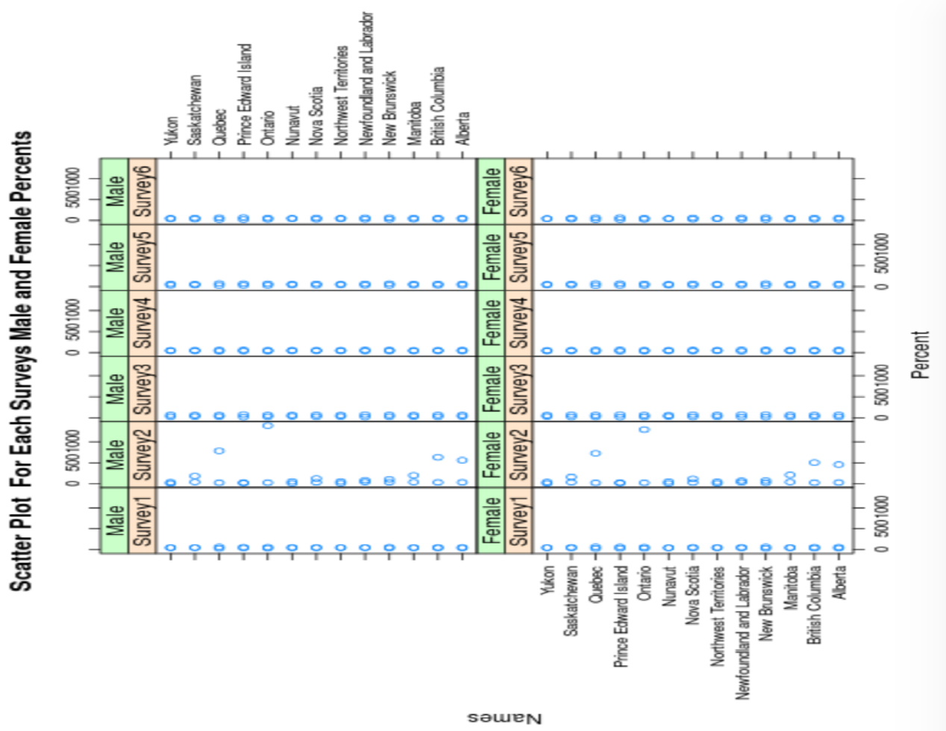
Graph 1.4 - XY-Plot of Male and Female Percentage Numbers for the Six Surveys
- Box and Whisker Section
Graph 2.1 – Box and Whisker Plot of the Good Numbers
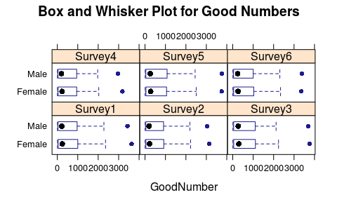

Graph 2.2 – Box and Whisker Plot of the Average Numbers
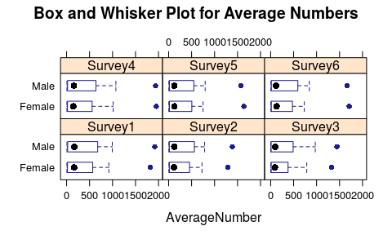

Graph 2.3 – Box and Whisker Plot of the Good Percentage Numbers
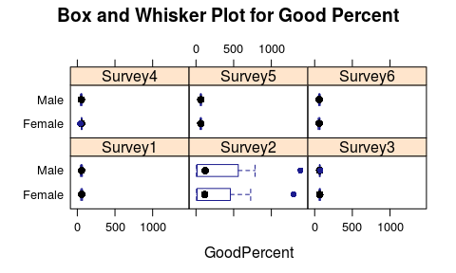
Graph 2.4 – Box and Whisker Plot of the Average Percentage Numbers
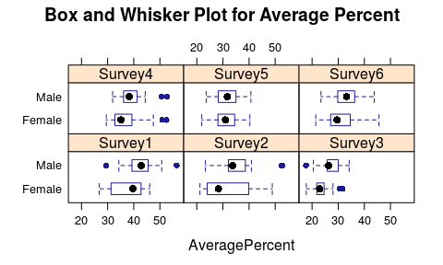

- Histograms Section
Graph 3.1 – Histogram of Survey 2 Good Male (GN1M), Good Female Numbers (GN1F), Average Male (AN1M), and Average Female Numbers (GN1F)
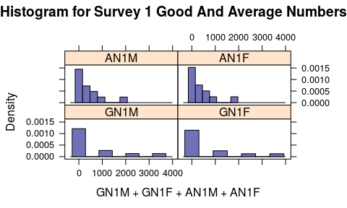
Graph 3.2 – Histogram of Survey 2 Good Male (GN2M), Good Female Numbers (GN2F), Average Male (AN2M), and Average Female Numbers (GN2F)
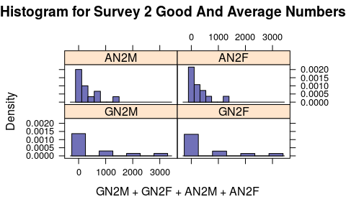

Graph 3.3 – Histogram of Survey 3 Good Male (GN3M), Good Female Numbers (GN3F), Average Male (AN3M), and Average Female Numbers (GN3F)
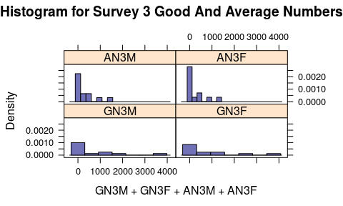

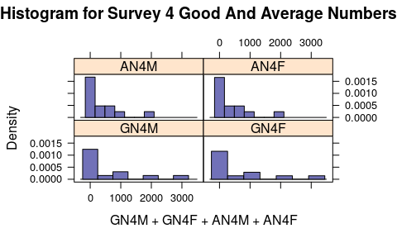
Graph 3.4 – Histogram of Survey 4 Good Male (GN4M), Good Female Numbers (GN4F), Average Male (AN4M), and Average Female Numbers (GN4F)

Graph 3.5 – Histogram of Survey 5 Good Male (GN5M), Good Female Numbers (GN5F), Average Male (AN5M), and Average Female Numbers (GN5F)
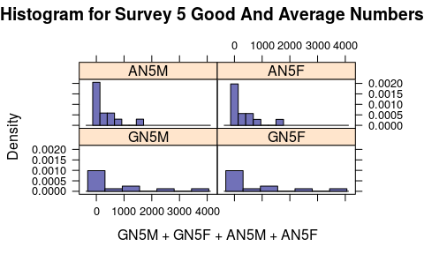

Graph 3.6 – Histogram of Survey 6 Good Male (GN6M), Good Female Numbers (GN6F), Average Male (AN6M), and Average Female Numbers (GN6F)
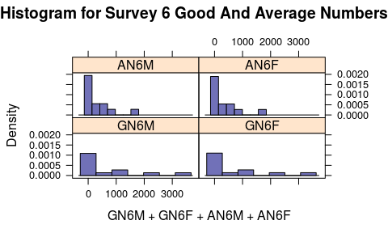

- Bar Graphs Section
Graph 4.1 – Survey 1 Good and Average Numbers

Graph 4.2 – Survey 1 Good and Average Percentages

Graph 4.3 – Survey 2 Good and Average Numbers

Graph 4.4 – Survey 2 Good and Average Percentages

Graph 4.5 – Survey 3 Good and Average Numbers

Graph 4.6 – Survey 3 Good and Average Percentages

Graph 4.7 – Survey 4 Good and Average Numbers

Graph 4.8 – Survey 4 Good and Average Percentages

Graph 4.9 – Survey 5 Good and Average Numbers

Graph 4.10 – Survey 5 Good and Average Percentages

Graph 4.11 – Survey 6 Good and Average Numbers

Graph 4.12 – Survey 6 Good and Average Percentages

Bibliography
- http://www5.statcan.gc.ca/cansim/a26?lang=eng&retrLang=eng&id=2530007&tabMode=dataTable&srchLan=-1&p1=-1&p2=9#F6

- http://www5.statcan.gc.ca/cansim/a26?lang=eng&retrLang=eng&id=2520090&tabMode=dataTable&srchLan=-1&p1=-1&p2=9#F1

- http://www5.statcan.gc.ca/cansim/a26?lang=eng&retrLang=eng&id=2520083&tabMode=dataTable&srchLan=-1&p1=-1&p2=9

- http://www5.statcan.gc.ca/cansim/a26?lang=eng&retrLang=eng&id=2520082&tabMode=dataTable&srchLan=-1&p1=-1&p2=9

- http://www5.statcan.gc.ca/cansim/a26?lang=eng&retrLang=eng&id=2520075&tabMode=dataTable&srchLan=-1&p1=-1&p2=9

- http://www5.statcan.gc.ca/cansim/a26?lang=eng&retrLang=eng&id=2520051&tabMode=dataTable&srchLan=-1&p1=-1&p2=9

- http://www5.statcan.gc.ca/cansim/a26?lang=eng&retrLang=eng&id=1160006&tabMode=dataTable&srchLan=-1&p1=-1&p2=9

- http://www5.statcan.gc.ca/cansim/a26?lang=eng&retrLang=eng&id=1160005&tabMode=dataTable&srchLan=-1&p1=-1&p2=9

- http://www5.statcan.gc.ca/cansim/a26?lang=eng&retrLang=eng&id=1160004&tabMode=dataTable&srchLan=-1&p1=-1&p2=9

- http://www5.statcan.gc.ca/cansim/a26?lang=eng&retrLang=eng&id=1160003&tabMode=dataTable&srchLan=-1&p1=-1&p2=9

- http://www5.statcan.gc.ca/cansim/a26?lang=eng&retrLang=eng&id=1160002&tabMode=dataTable&srchLan=-1&p1=-1&p2=9

- http://www5.statcan.gc.ca/cansim/a26?lang=eng&retrLang=eng&id=1160001&tabMode=dataTable&srchLan=-1&p1=-1&p2=9

- http://www5.statcan.gc.ca/cansim/a31?lang=eng&actionMode=tableDefinitions&id=3301

- http://www5.statcan.gc.ca/cansim/a26?lang=eng&retrLang=eng&id=1110006&tabMode=dataTable&srchLan=-1&p1=-1&p2=9

- http://www5.statcan.gc.ca/cansim/a26?lang=eng&retrLang=eng&id=1110005&tabMode=dataTable&srchLan=-1&p1=-1&p2=9

- http://www5.statcan.gc.ca/cansim/a26?lang=eng&retrLang=eng&id=1095355&tabMode=dataTable&srchLan=-1&p1=-1&p2=9

- http://www5.statcan.gc.ca/cansim/a26?lang=eng&retrLang=eng&id=0510020&tabMode=dataTable&srchLan=-1&p1=-1&p2=9

- Liou, K. T, and E. G Savage. “Citizen Perception of Community Policing Impact.” Public Administration Quarterly, vol. 20, no. 2, 1996, pp. 163–179.

- Nalla, Mahesh K, and Manish Madan. “Determinants of Citizens’ Perceptions of Police-Community Cooperation in India: Implications for Community Policing.” Asian Journal of Criminology : An Interdisciplinary Journal on Crime, Law and Deviance in Asia, vol. 7, no. 4, 2012, pp. 277–294., doi:10.1007/s11417-011-9110-2.

- Frank, James, et al. “Exploring the Basis of Citizens&Rsquo; Attitudes Toward the Police.” Police Quarterly, vol. 8, no. 2, 2005, pp. 206–228.

- Hauser, Will, and Gary Kleck. “The Impact of Police Strength and Arrest Productivity on Fear of Crime and Subjective Assessments of the Police.” American Journal of Criminal Justice : The Journal of the Southern Criminal Justice Association, vol. 42, no. 1, 2017, pp. 86–111., doi:10.1007/s12103-016-9334-x.

